Israr

Lab PF

**Task 1**

#include<iostream>

#include<string>

using namespace std;

int main()

{

string date;

cout<<"ENter the date (DD/MM/YYYY) : ";

getline(cin,date);

cout<<endl<<date;

int len=date.length();

string d=date.substr(0,2);

string m=date.substr(3,2);

string y=date.substr(6,4);

cout<<endl<<"date : "<<d;

cout<<endl<<"month : "<<m<<"\nYear : "<<y;

}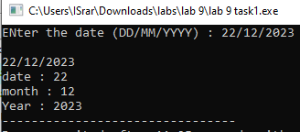

**Task 2**

#include<iostream>

using namespace std;

int st(string);

int main()

{

int a;

string str;

cout<<"\nEnter the String : ";

getline(cin,str);

a=st(str);

cout<<"\nNumber of words : "<<a;

}

int st(string str1)

{

int len=str1.length();

return len;

} 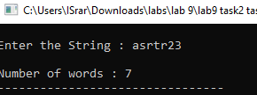

**Task 3**

#include<iostream>

using namespace std;

string net(string);

int main()

{

string output,num;

cout<<"\nEnter your Number : ";

cin>>num;

output=net(num);

cout<<"\nYour Network is "<<output;

}

string net(string no)

{

string ntw;

string network;

network=no.substr(0,4);

if(network=="0300")

ntw="Mobilink";

else if(network=="0315")

ntw="Zong";

else if(network=="0333")

ntw="Ufone";

else if(network=="0345")

ntw="Telenor";

return ntw;

}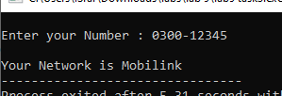

Task 4

#include<iostream>

using namespace std;

int main()

{

string fname,lname;

cout<<"\nEnter Your first name : ";

cin>>fname;

cout<<"\nEnter your Last name : ";

cin>>lname;

cout<<endl<<fname+'.'+lname<<"@iba-suk.edu.pk";

} 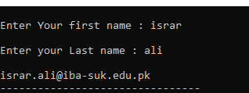

Task 5

#include<iostream>

#include<string>

using namespace std;

string my_lower(string);

int main()

{

string str,res;

cout<<"\n Enter your string here : ";

getline(cin,str);

res=my_lower(str);

cout<<"\nHere is lower case : "<<res;

}

string my_lower(string g)

{

int len=g.length();

int arr[len];

for(int i=0;i<len;i++)

{

if(g[i]>=65&&g[i]<96)

{

g[i]+=32;

}

}

return g;

} 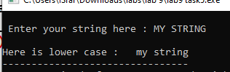

**Task 6**

#include<iostream>

#include<string>

using namespace std;

string my_upper(string);

int main()

{

string str,res;

cout<<"\n Enter your string here : ";

getline(cin,str);

res=my_upper(str);

cout<<"\nHere is upper case : "<<res;

}

string my_upper(string g)

{

int len=g.length();

int arr[len];

for(int i=0;i<len;i++)

{

if(g[i]>=96)

{

g[i]-=32;

}

}

return g;

}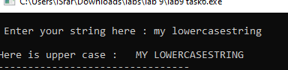

**Task 7**

#include<iostream>

#include<string>

using namespace std;

string pld(string);

int main()

{

string str,res;

cout<<"\nEnter your string : ";

getline(cin,str);

res=pld(str);

cout<<endl<<res;

}

string pld(string inp)

{

bool check=false;

string result, arr;

int len=inp.length();

for(int i=0;i<len;i++)

{

arr[i]=inp[i];

}

int p=len-1;

for(int i=0;i<len;i++)

{

if(arr[i]==inp[p]) //asrar rarsa

check=true;

else

check=false;

p--;

}

if(check==true)

result="The string is pailindrome";

else

result="The string is not pailindrome";

return result;

} 